Reminders!

America To Go (ATG) is a BearBuy Punch-out catalog used to purchase food for business meetings and campus events. America To Go contains menus from the University’s preferred local restaurants and caterers for pickup and delivery to campus locations.

Please allow sufficient time for departmental review and approval, as well as time for caterers to prepare and deliver your order (standard lead times are provided for each caterer). America To Go will email an order confirmation to the PO Owner once the caterer accepts the order.

One Caterer per ATG order:
- You cannot mix items from different caterers within the same ATG order. Only add items from one caterer per ATG order.

Editing an America To Go order before it has been fully approved in BearBuy:
- While in a draft cart, Shoppers can select Modify Items to open the ATG
Punch-out order and edit the order before it is submitted for approval.

Changing your America To Go order after it has been fully approved in BearBuy:
- Changes to items/quantities/pricing: Call America To Go’s 24/7 Customer Care line (866) 284-8646 for assistance. Do not perform or request a BearBuy Change Order. Any additions to the order will be handled through the Voucher Match Exception Process.
- Changes to Chart of Account (COA) field(s): Changing COA field(s) can be performed provided the PO has not been fully invoiced.

Guest List:
- A guest list should be detailed and include, names, titles and affiliation with the University. If it is impractical to list each guest based on the open nature of the event, the documentation does not need to include individual names and titles. The requirement is the same regardless of dollar, amount or whether exceptional approval is needed.

Exceptional Approvals:
- Exceptional approval is restricted to the Chancellor and the Chancellor’s named designees. This authority cannot be re-delegated by the designees to other individuals. For additional information visit the Entertainment website http://controller.berkeley.edu/who-can-approve-entertainment-expenses.

Entertainment Form:
- A completed and signed entertainment form (http://tinyurl.com/EntertainmentForm) must accompany every America To Go catalog purchase. For orders <$1,000 the host signature is not required.

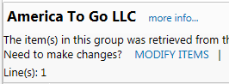

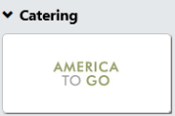
- Navigate to the Catering category on the Home/Shop page and select the America To Go punch-out sticker. A separate ATG browser window will open.

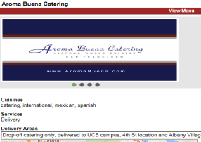
- Time: Select a delivery/pick-up date and time: Select the time and date you wish the items be delivered/picked up. The calendar defaults to the current work week and shows available delivery/pick-up time slots by every half hour.

Modify month: If the desired week is not visible, select the month icon on the left hand side to expand. Select the ►icon to move to the following month and select your preferred delivery/pick-up week.

Select a day: After the calendar has updated, navigate to the column of your preferred day.

Select a time: Hover over your desired delivery/pick-up time. You can increase or decrease the time slots by increments of 5 minutes by selecting the or arrows.
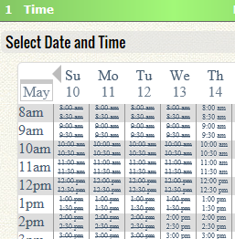
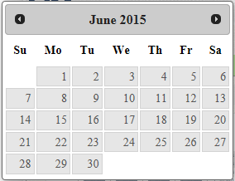
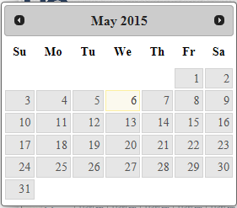
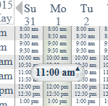

ATG Punch-Out Job Aid May 2015
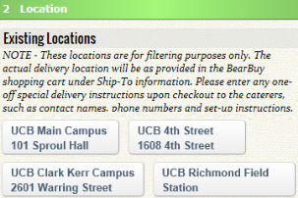
- Select a location: Select a campus hub for delivery. You should select the campus area closest to where the food will be delivered. This address location is for filtering, reservation and tax purposes only. You will provide a building name and room number for delivery when selecting the Ship To location on the cart later in the process.

4a. Select a Restaurant: Search and Filter – Restaurant search results will appear on the right side of the page based on the campus hub location selected. Filtering by cuisine, service type and/or price will reduce the number of results. By default, caterers that delivery to your location will be visible. Some restaurants are listed twice as they offer different menus for restaurant and catering orders. For multi-day events, see Custom Orders (step 4c).
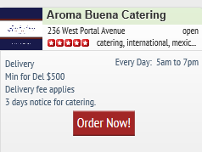
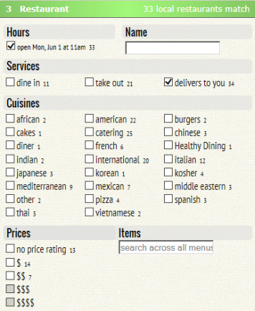
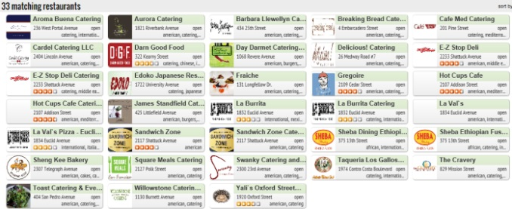
Hover over the restaurant name for a snapshot summary. To view a restaurant menu, select Order Now! from the summary window.

Page 1 of 3
Alternatively, click on the restaurant name to view additional information such as delivery zones, delivery fees, restaurant description, etc. To access the restaurant menu, select the View Menu link.

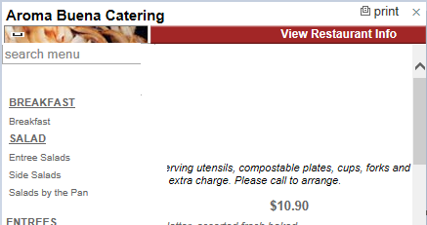
4b. Select a Restaurant: Viewing a Menu- The menu categories are listed on the left side. Items within a category will appear to the right. The search bar at the top of each menu can be used to locate specific food items within a menu.

To print the menu, select the print icon in the upper right side of the menu.

4c. Special Requests and Custom Orders: Many caterers are able to create custom orders to meet your catering needs. Call caterers directly to build and add a custom order to the Punch-out. After a Caterer uploads your custom order to the Punch-out, you will be able to access it from the caterer’s menu under the Custom Catering section.
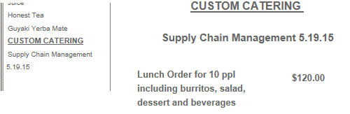
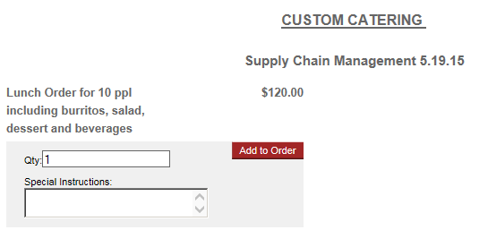
Click on the order description.

Click Add to Order to add the custom catering to your order.

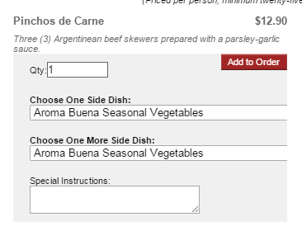
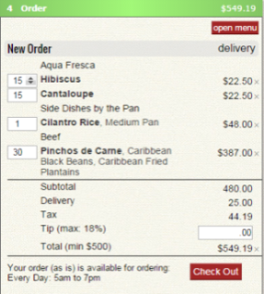
4d. Browse the menu options. To order an item click on the item name to show ordering options. Enter the desired quantity in the Qty box.
a
b
c
d

The Special Instructions note section can be used for additional order information. This note will be sent to the caterer.

Click Add to Order to add the item to your order.

ATG Punch-Out Job Aid May 2015
5. Once the item is added to your order you can:
- Change the order from delivery to take-out
- Increase/decrease the quantity of an item by hovering over the item quantity and selecting the ↑or ↓ arrows.
- Enter the tip amount. The maximum allowable tip is 18% of your order. Please consider delivery and service fee charges when considering the tip amount. If tip amount entered exceeds 18%, the tip will auto-adjust to the maximum amount (18%).
- When your order is complete, click the Check Out button.
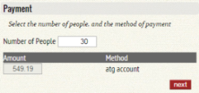
6a. Number of People: Enter the number of guests in the Number of People section. This is used to calculate the per person cost of food in compliance with entertainment policy. Click next.
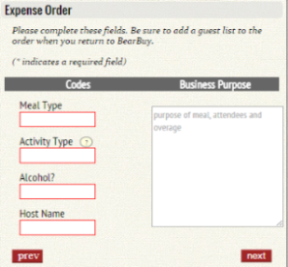
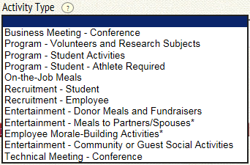
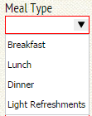
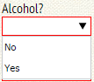
6b. Expense Order: Using the drop down menus, select the Meal and Activity type and indicate if alcohol is included in the order. Enter the Host name and Business purpose. Click next.
Alcohol: There is a box to identify if alcohol will be served. Standard America To Go menus do not include alcohol. Alcohol is rarely served and requires special licensing. Caterers may be able to provide this as a custom order. If so, departments are required to seek additional authorization and licensing for their event.

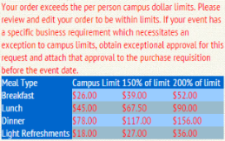
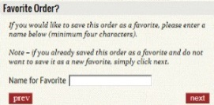
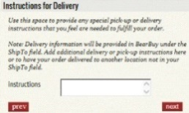
Note: If your event costs are higher than the policy limits, you will receive a warning notice as illustrated to the left. You are strongly urged to remain within limits. Additional approval for policy exceptions must be obtained prior to placing an order with a restaurant.

6c. Instructions for Delivery: If desired, add delivery instructions for the caterer such as on-site contact information, loading-unloading instructions, room directions, etc. Click next.

6d. Favorite Order?: If you wish to save this order as a favorite to quickly recreate this order in the future, enter a name in the Name for Favorite box (minimum four characters). If you do not wish to save this order to your favorites simply select next.

You can access a list of your favorite orders by clicking the Favorites link at the upper right corner of your screen. Please note that all entertainment information will carry over to your new order.
Page 2 of 3
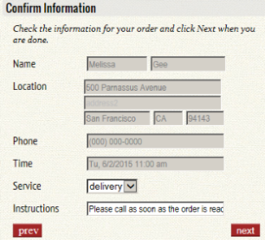
6e.Confirm information: The address in this section is the general campus area selected on step 3. The order delivery address must be added in the Ship to location on your BearBuy cart.

The special delivery instructions you added in step 6c are carried over. Edit your note if needed.

Orders default to delivery service. You can change it to pick up or dine in service (if available) by selecting the Service drop down menu.

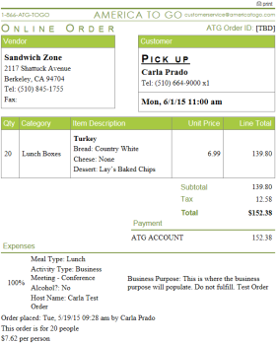
Order information including all itemized items along with business and entertainment information you previously entered will appear to the right of the screen.

To print the America To Go Order information, select the print icon in the upper right corner of this screen.

Once you have confirmed your information, click next.

6f. Send the Order: America To Go asks you to review your order one last time. It is extremely important that you carefully review your order for accuracy. Click submit now to return your order to BearBuy as a draft shopping cart.
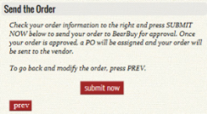

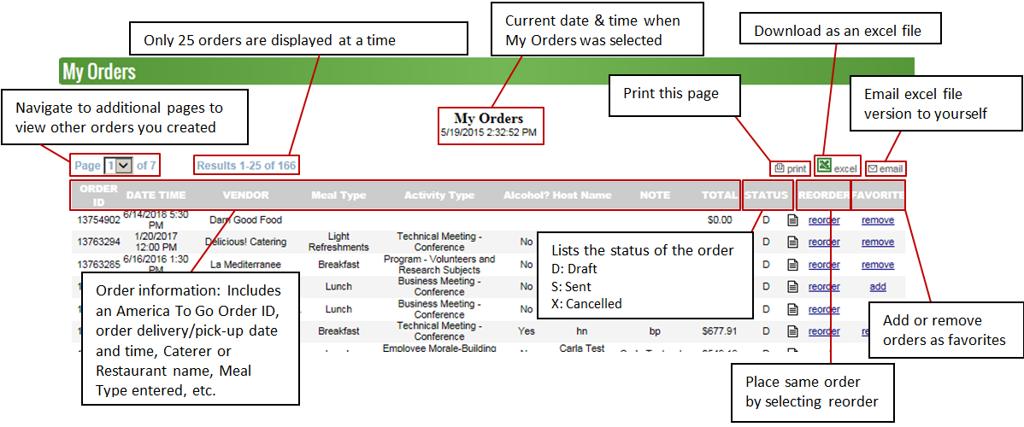

7. Your ATG order is now in your BearBuy cart. To attach the entertainment form and edit/verify the ship to address, click the View Cart Details button.
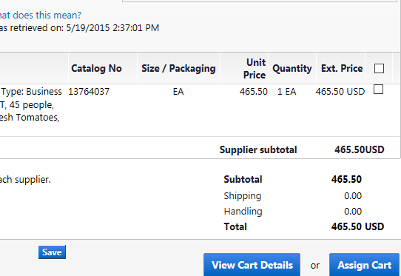

Note: The order subtotal will be the total order amount not including tax and tip. Tax and tip will be visible on the voucher not on the requisition or PO.

8. From the cart details, navigate to the Requisition tab >Shipping sub-tab.

9. From the Shipping sub-tab, verify that the Ship to address is your desired delivery address. If it is not, select the edit button, click to choose a different address and search from org addresses to select the correct delivery address.

10. To add the entertainment form and/or additional comments to this order, navigate to the Comments tab, and select Add comment.

Click the browse button to select the documents including the entertainment form, guest list, and the signed approval (if applicable). Select the Add Comment button.

11. Complete the shopping process: From this point forward, orders should be completed as a standard requisition in BearBuy. Instructions on completing a BearBuy requisition can be found on the Supply Chain Management BearBuy Instructional Resources site (http://supplychain.berkeley.edu/bearbuy/instructional-resources-0).
ATG Punch-Out Job Aid May 2015
Page 3 of 3

My Orders:
You can access a list of all orders associated to your America To Go Punch-out by clicking the My Orders link at the upper right corner of your screen. Please note that all entertainment information will carry over to your new order.

